**Servet Can Celik**

**S2-CB06 4590805**

|  |
| --- |
| **Smiley Web App** |
| Ideation Document |
| Smiley is a social media platform where users connect through their own accounts and post publicly from these accounts or see other users' posts, like or dislike them, and send their comments. Due to the unique style of this website, the main post must contain an image. |
| Git Repository Link :  https://git.fhict.nl/I489394/s2-cmk-wad-servet-can-celik-web-app-smiley.git |

**Website Purpose**

The main purpose of this website is to create a platform where talented members can share the content they produce with other people.

**Target Audience**

Although this website targets a large number of people, the main target audience is considered to be millennials and generation z.

This website is a multi-user platform that aims for people to connect anonymously and share posts with visual content. Each user has a unique username. In addition, each user can have an avatar. Due to the special style of the site, each main post must have a visual content. Main posts is open for viewing by all users. In addition, all users have the ability to like or dislike or comment on posts.

This website is a multi-user platform that aims for people to connect anonymously and share posts with visual content. Each user has a unique username. Also, each user can have an avatar. Due to the unique style of the site, every main post must have a visual content. Main posts are open to view by all users. Also, all users have the ability to like, dislike or comment on posts.

Although Smiley was established as a website based on displaying funny posts, it also contains many different sections such as Animal, Perfect, Car, Politica, Random...

In addition to its existing features, it is aimed to expand this site so that users can send direct messages to others.

**Site Map:**

The images below will show some example of wireframes;

Main Page

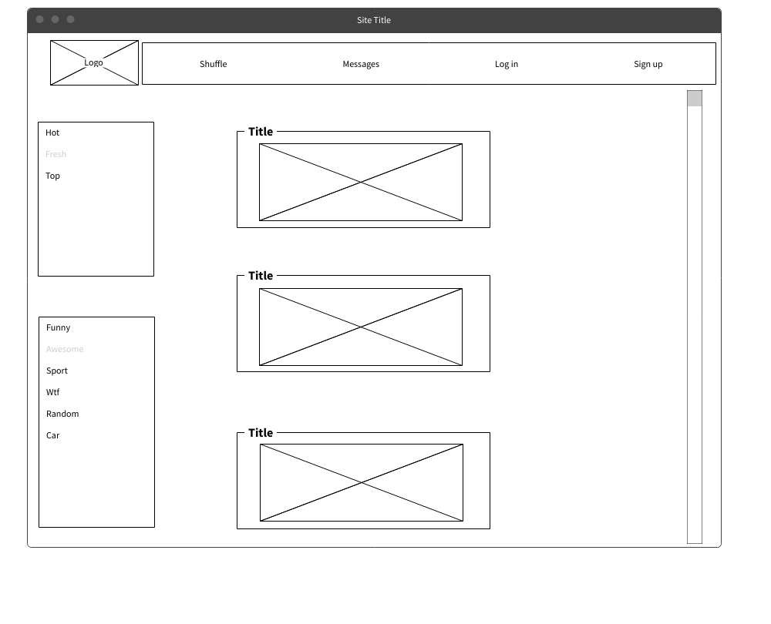

Comment Page

Sign Up Page

Log In Page

